**Term Project Assignment (10 points of your final project grade).**

**Note. Due 11/12 – Please watch the video, which will guide you through this first part of the project.**

There will be a number of assignments associated with a Term Project. Now, having looked at some data sources, and learned enough GIS, we will begin to work on the project.

A GIS Project can take many forms and there are many types of applications depending on the industry or subject (e.g., business, science, public health, pubic safety, etc. Our approach will be one applicable to most areas.

We have enough techniques to be able to create a professional GIS application (and may learn a few more):

* Creating and navigating a map project
* Downloading base layers from the Internet
* Downloading data (Excel) from the Internet
* Creating color-coded maps
* Joining layers
* Editing the attribute table (e.g. create attributes, calculate fields)
* Searching layers by attribute and location with simple and *complex queries*
* Geocoding addresses
* Adding XY-Data
* Applying visualization Techniques
  + Scale
  + Data Frames
  + Transparency
  + Creating density/heat maps
* Building a map for publishing with a title, legend, north arrow and scale bar
* Learning about data and data sources
  + Shapefiles
  + Demographic data
  + Joinable spreadheets
  + Point files with addresses
  + Point files with Longitude and latitude

We will create a GIS Model by selecting a base map, point layer and demographic layer. This type of GIS application is to try to understand or get perspective about the “location” of point. The insight can either be about the points specifically or the location or neighborhood and its potential influence. For example, if the points are crime incidents one could have the following research questions:

1. Is there more or less crime in low income neighborhoods?
2. Is there more or less crime in neighborhoods where there are more renters than owners?
3. One could “compound” the questions and analyze if there is a correlation between income and households to the incidence of crime.
4. With another point layer (e.g. liquor stores), is there more crime near or further away from the stores.

For the first assignment we’ll use specific base, point and demographic layers. In the next part of the project, you will choose your own layers

**Selecting a County base-layer**

1. Create a folder for the term project (similar to the weekly folders).
2. Download the New York State Counties from US Census Tigerline: <https://www.census.gov/geographies/mapping-files/time-series/geo/tiger-line-file.html>
3. In new map, add the NYS Counties
4. Save the map as *yourlastnameTP1-CollegeColor-Coded*

**Downloading a demographic layer using Social Explorer**

There are a number of websites that collect and disseminate US Census data, crime data, economic data, etc. Most do not have this data already in a shapefile and so we must download in Excel and join to our base layer.

As we have done previously, we will use Social Explorer. You must have the “Professional License” usage from Pace University.

Following the instructions from a previous assignment:

1. Log into Social Explorer (http:/www.socialexplorer.com).
2. Choose *Tables* at from the list on the right
3. Select *American Community Surveys (5-year Estimates)*
4. Select *American Community Surveys (ACS 2010-2014)*
5. In the Geography pull-down menu select *County*
6. Select *New York*
7. Select *All counties in New York*
8. Select *Add*
9. Proceed to *Tables*
10. *Select Begin Report*
11. Download the Data for New York Counties

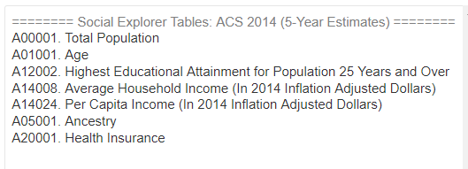

1. We won’t use all of these tables.
2. “Show Results”
3. Go to “Data Download”
4. In your Project folder:
5. Download the DBF friendly CSV file
6. Download the Data Dictionary
7. To use the spreadsheet, you will have to clean it up:
   1. Check the column headings are 10 characters or less
   2. *For this spreadsheet, edit out the “SE_” in the first row attribute names.*
   3. *NOTE: this is not in the video. The beginning of the 3rd video (Analysis) discusses this.*
   4. Remove blank columns
   5. Determine which attribute you will join around (look at the Base Map attribute table) and modify any values if necessary (e.g. may have to adjust the county name).
   6. Check St. Lawrence County (look if both Tigerline file and Social Explorer file both have “.”). Make them the same.
8. Add the spreadsheet to the map
9. Join to the New York County Base layer (NAMELSAD10 and GEO_NAME).
10. Export the joined layer as a shapefile (right-click->Data->Export Data)

**Selecting a point layer**

1. We will select a point layer that has a good distribution throughout the United States.
2. For this we use an new Data source: Homeland Infrastructure Foundation-Level Data (HIFLD): <https://hifld-geoplatform.opendata.arcgis.com/>
3. While it is connected to ESRI ArcGIS Online – you do not have to log in to access these files.
   1. Explore the categories for a dataset that might interest you. One or more of these may become part of your Final Project.

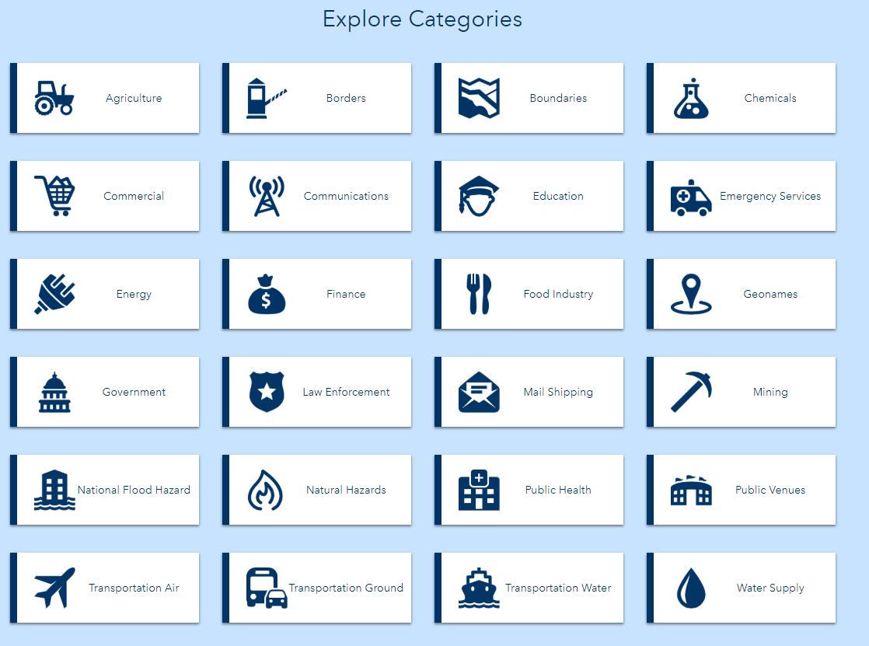

* 1. The dataset should have the following characteristics:
     1. There should be a spatial dataset associated with it (otherwise much more work in that we have to clean up the spreadsheet, join, create a new layer)
     2. Since these are national datasets, it should have more than 1000 rows or points for a good distribution.
     3. We will filter for New York State

1. Here is a rundown of some interesting datasets:
2. Commercial
   1. Fortune 500
3. Communications
   1. Cellular Service Areas
   2. Cellular Towers
   3. Area Code Boundaries
4. Finance
   1. Credit Unions
   2. FDIC Banks
5. Law Enforcement
   1. Prisons
6. Natural Hazards
   1. Earthquakes (Others-tornados, Volcanic Eruptions)
7. Transportation
   1. Amtrak Stations
8. Education
   1. Supplemental Colleges
   2. Colleges and Universities
   3. Public Schools
9. Public Health
   1. Pharmacies
   2. Nursing Homes
   3. Urgent Care
   4. Veterans Administration Facilities
   5. Hospitals
10. EPA
    1. Solid waste landfill
11. Emergency Services
    1. Red Cross
    2. Fire Stations
12. Mining
    1. Coal Fields
    2. Mines and Mineral Resources
13. Public Venues
    1. Sports
    2. Mobile Home Parks
14. For this example, we will choose Colleges and Universities. For your project, you will choose one more others.

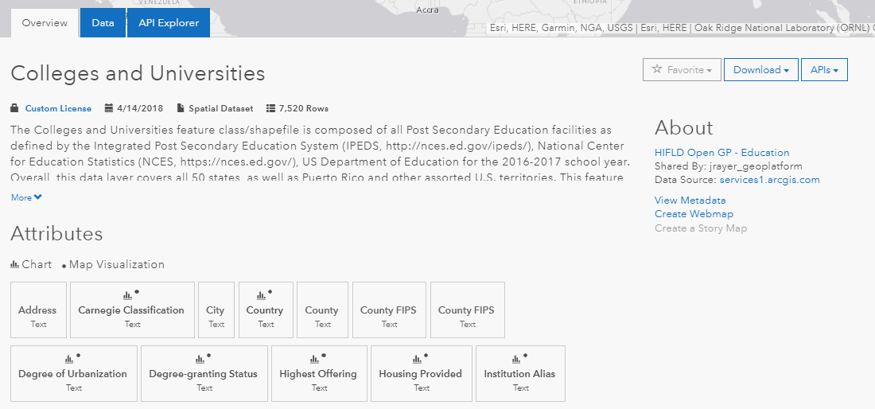

* 1. Clicking on the Data tab will show the data as a table and you can tell if this will be a suitable file before downloading. We want a dataset that has “point” addresses.

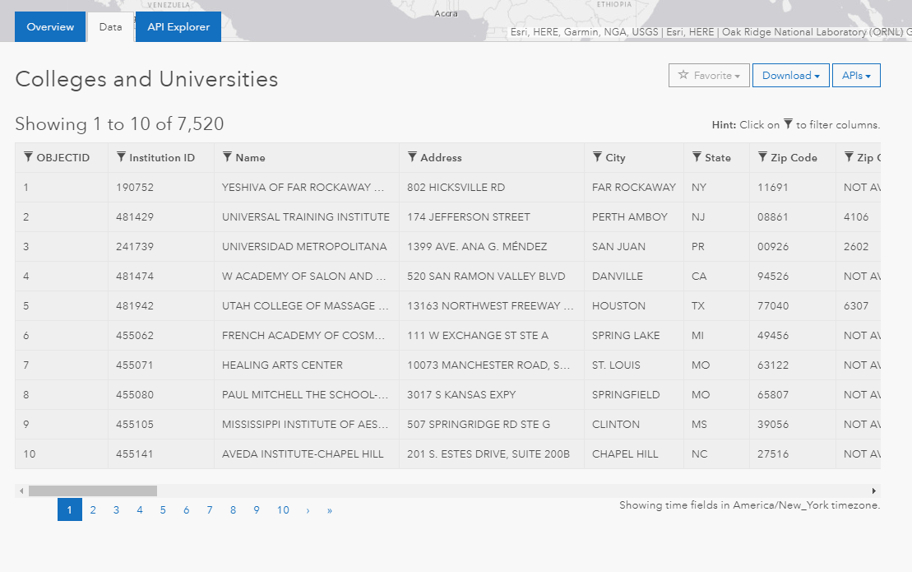

* 1. Clicking on Download (on the right) will give you file format options. Choose shapefile. Download, and unzip in your Term Project Folder.

1. Add the Colleges and Universities to your map. It will have an extent that spans the US.
2. In the same way we selected streams for the Hudson Valley, create a layer for Colleges and Universities (Select by Attribute )
   * + 1. Select by Attribute (“State” = ‘NY’)
       2. Create a layer from the selection

**Putting it together in ArcMap**

1. Remove the unnecessary layer keeping
   1. New York State base map with joined demographic layer
   2. New York State Colleges and Universities layer (the new layer that was created).
2. Create a color-coded map using “Per Capita Income”. You have to look at the Dictionary .txt file to make your choice.
3. When the map is complete, add a title (based on the color-coded map For example “Per Capita Income and the Distribution of Colleges and Universities. Add background color, Title, etc.
4. Export and upload a jpg of the map (yourlastnamecountiescolleges01.jpg).
5. Save the map

**Analyzing the results using counts**

What does the color-coded ma show us? It is a good visual representation of College density. We could use a heat map to make the visualization more explicit. Can we ask other questions?

For this type of problem (points and demographics),we could try to understand more about where the colleges are located (high or low income areas. One way to quantify this is by counting how many there in each of the counties and then ask:

*Which counties have high (or low) number of colleges AND a high (or low) per capita income)?*

**To do this we need to count the points.**

1. The color-coded map has been saved, create a new map using File-> Saving as-> *yourlastnameTP1-CollegeAnalysis*
2. We don’t need the color-coded mapFJoin the Colleges layer to the Demographic layer.
3. Note, that they have no field in common and more importantly, there are more points than polygons.
4. The join we use will give us a count and create a new layer (shapefile).
5. In the join, select “Join data from another join based on spatial location”
6. While you can see other statistics options, the “Count” of points in each polygon will be created as an attribute in another column.
7. Make sure the shapefile will be created in your Project folder
8. Name it *NYSDemographicsCounts.shp.*
9. Click Ok
10. It will automatically add the shapefile to your map.
11. You can remove the original NYSDemographics since the new one has the demographics and the count.

**Answering the research questions: Which counties have a high number of colleges and low per capita income?**

1. Look at the attribute table for the demographic layer. Sort the per-capita-income column and a select value in the bottom half (30,000 is a good one).
2. Sort again, look at the count_ column, and choose a value in the top half (10 is a good one).
3. Select by attribute using with a compound query using the values you chosen:
4. Income < than the 30000 AND Count_ > than 10
5. Create a map from the selections (create a layer, export to create a shapefile)
6. In layout view add the Title, etc.
7. Export as jpg: yourlastnamecountiescolleges02.jpg

**Enhancing the Map**

1. Enhance the mini-project by reversing the question above (low number of colleges and high per capita income) and show a comparison.
2. Create a new Data Frame and copy the layers from the original to the new Data Frame.
3. Using these layers, create a new map (within the data frame)
4. Display as a side-by side map.
5. Export as jpg: yourlastnamecountiescolleges03.jpg

**What is due 11/12/2019**

1 word file with your 3 .jpgs

yourlastnamecountiescolleges01,jpg

yourlastnamecountiescolleges02.jpg

yourlastnamecountiescolleges03.jpg